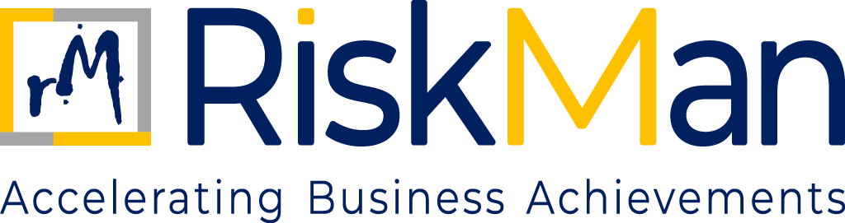
Health and Safety Policy
TABLE OF CONTENTS
Health and Safety Policy

- Objective………………………………………………………………………………………………………………………….………3
- Policy……………………………………………………………………………………………………………………………………….3

HEALTH AND SAFETY POLICY
- OBJECTIVE

At RiskMan Consulting, we are committed to ensuring the health, safety, and welfare of our employees, clients, contractors, partners and all others who may be affected by our activities. As an organization specializing in risk management and consulting services, we recognize our responsibility to provide a safe and healthy working environment in compliance with the local Health and Safety at Work policy.

We aim to:
- Prevent accidents and cases of work-related ill health.
- Provide clear instructions, information, and adequate training to ensure employees are competent to carry out their work safely.
- Engage and consult with employees on health and safety matters.
- Provide and maintain safe equipment and a safe working environment.
- Regularly assess risks and implement control measures.

- POLICY

These policies are vital for building a safe, efficient, and legally compliant workplace.

- Workplace safety
- Office areas are regularly inspected for hazards (electrical safety, ergonomic setups, etc.).
- Fire extinguishers and first aid kits are available and routinely checked.
- Emergency exits are clearly marked and unobstructed.

- Workplace Travel Guidelines
- Avoid High-Risk Transport: RiskMan team members are strongly advised against using motorbikes, Uber Moto, Rapido, or similar two-wheeled transport services for commuting or work-related travel due to increased accident risks.
- Preferred Transport Options: Utilize Metros, or public transport options for all travel needs.
- Verify Transport Detail: When using cabs or ride-sharing services, always verify that the vehicle and driver match the provided details through the mobile app for safety. Ensure to share your cab details to any concerned team member/ emergency contact in your family for any late-night travel situations.

- Healthy and Safety Gear
- Mandatory Helmet Use: If using a motorbike is unavoidable, please wear a helmet mandatorily to meet safety standards and ensure that the helmet is securely fastened at all times during the motorbike ride.
- Additional Safety Measures during client factory/ site visits: Wear appropriate safety gear such as gloves, jackets with armor, safety helmets, safety shoes, earbuds, and reflective clothing to enhance visibility and protection (whatever is required as per the factory/ site’s safety protocol in order to visit the area/s.

- Security
- Late Night Travels: Always inform your reporting manager in case of late-night travels and keep them informed once you reach. For any support, please do reach out to concerned partners.
- Visitor Protocol: Ensure no visitors are invited to client premises.
- Secure Personal and Official Belongings: Keep personal and official belongings in secure areas and do not leave valuables unattended.

- Emergency Procedures
- Emergency Contacts: Update your emergency contact details and share back for record purpose with your buddy marking a copy to prasen.pal@riskman.in. Respective buddy to ensure for any new hire this information is collected and shared.
- Evacuation Plan: Familiarize yourself with the office's evacuation plan and participate in regular drills (including for respective client offices).
- First Aid: Be aware of the locations of first aid kits and emergency medical facilities within the workplace (including for respective client offices).

- Cybersecurity
- Device Security: Ensure all work devices are password-protected and utilize two-factor authentication wherever possible.
- Data Protection: Be vigilant about data protection policies and avoid sharing sensitive information over un-secured channels.
- Report Suspicious Activity: Report any suspicious emails, messages, or behaviour to your reporting Partner immediately. DO NOT FORWARD ANY PHISHING EMAIL TO TEAM MEMBERS (STRICTLY AVOID SPREAD).
- Behaviour Cautious: Stay vigilant and always be cautious on behaviour norms. If there is anything unusual, double check/ reach out the person on call separately to verify the source before clicking or responding.

By adhering to these guidelines, you all can help us maintain a safe and secure working environment.
Your safety and security are our utmost priority.

